**EXPERIMENT 2**

Aim :- Creating a LAMP Instance in the AWS CLI

**B] Creating a LAMP Instance in the AWS CLI**

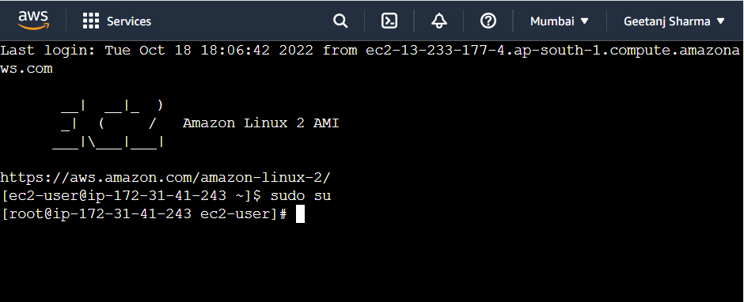

* Ec2 instance is connected. 10. Type the commands to intall LAMP (linux, apache, mysql, php) server.
* Firstly, type sudo su to become the root user.
* To update all the packages in your instance type “yum update -y”

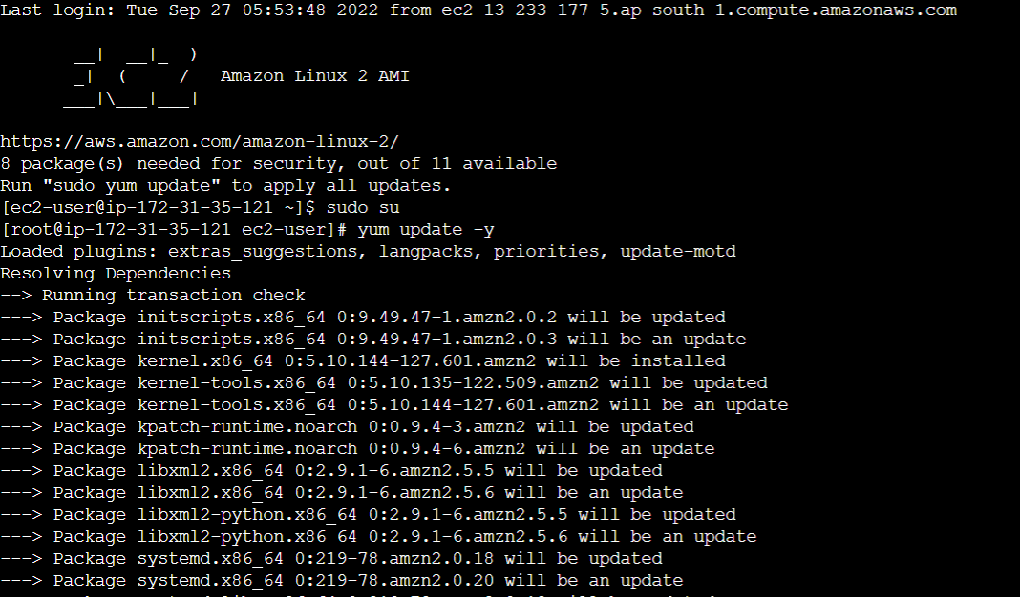

* To install Apache server in linux, type “yum install httpd”

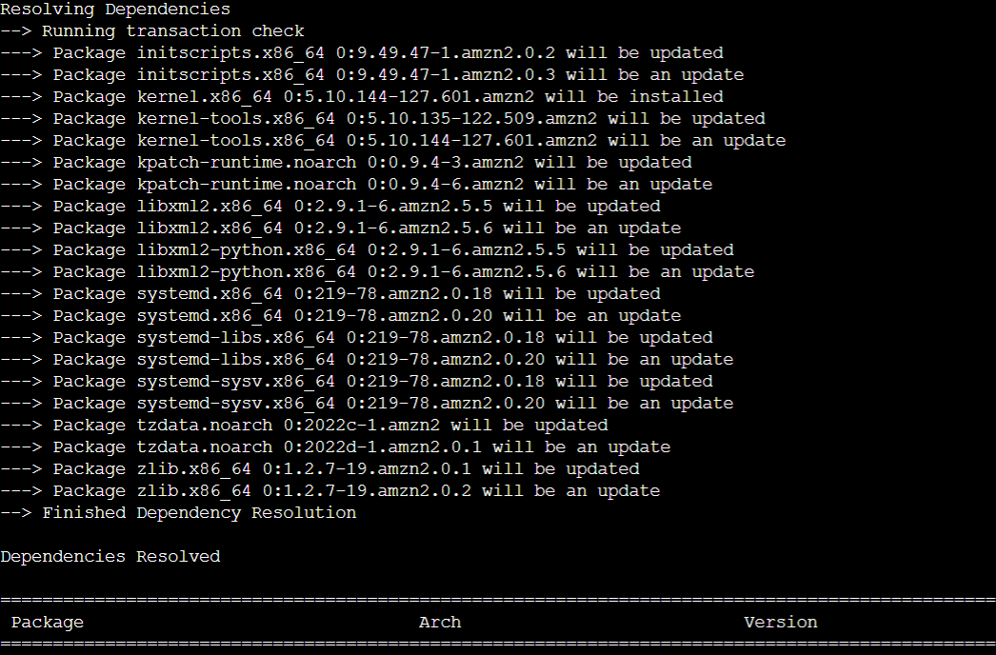

* To install mysql or mariadb type “yum install mariadb mariadb-server”.

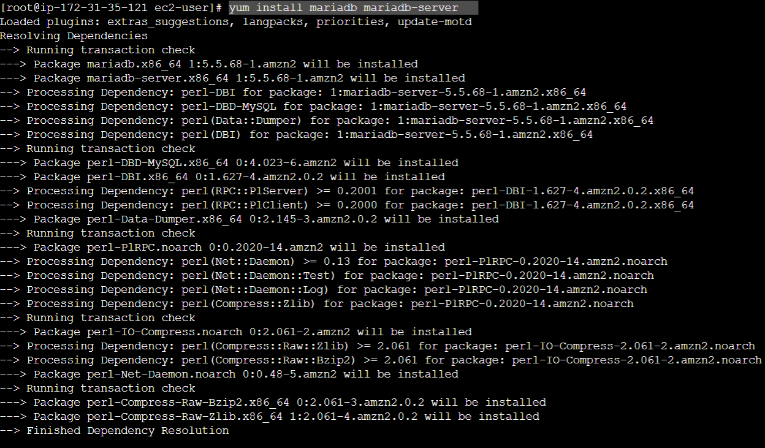

* To install php, type “yum install php php-mysql”.

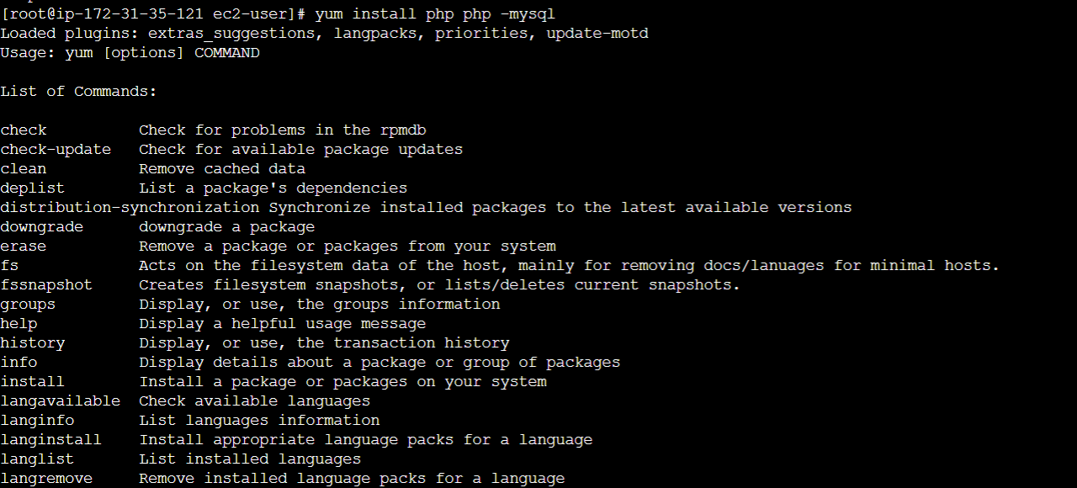

* Type “yum search php” to see all the packages installed in the server.

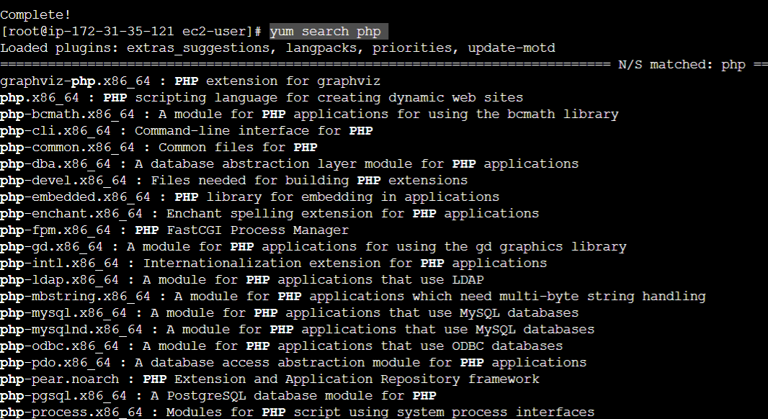

* Enabling the mariadb server.

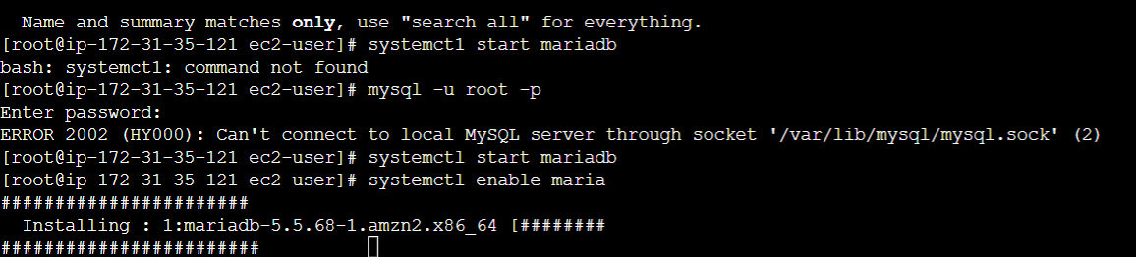

* After enabling httpd (apache server) , go to the directory where cd /var/www/html/ .

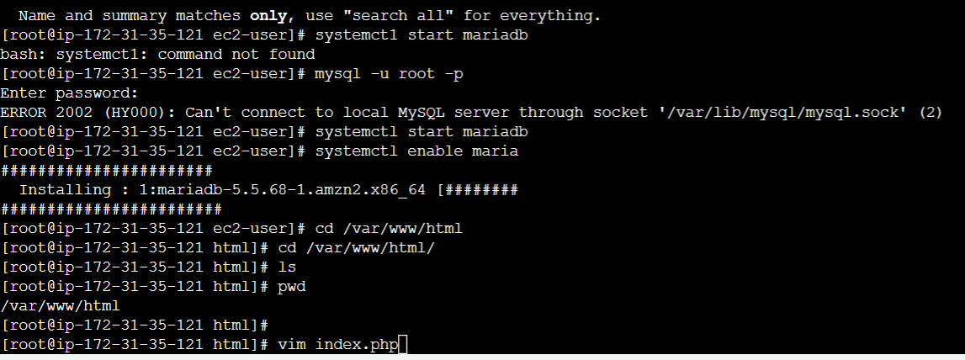

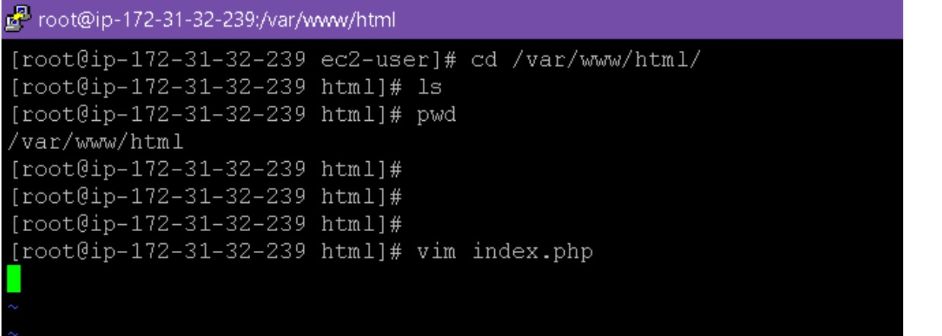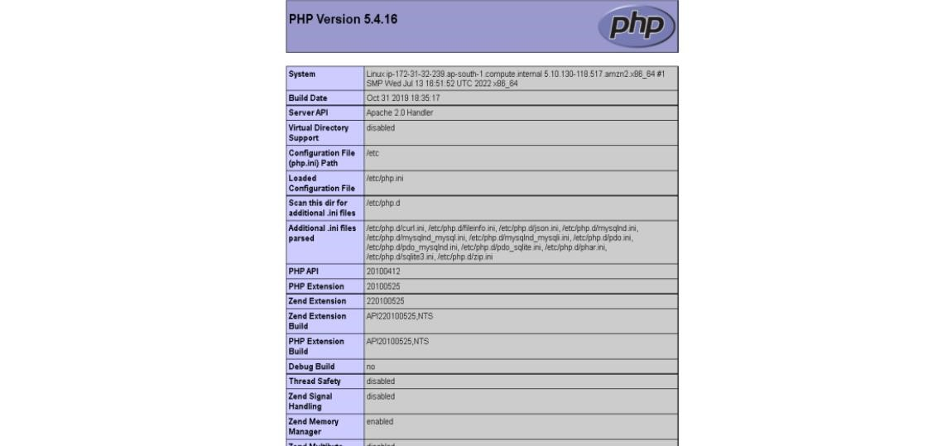

Result:

LAMP server is successfully created using AWS CLI